# Nama : Rangga Pebrianto

# NIM : G6601231006

# PERTEMUAN 8

**Machine Learning berbasis Algoritma Tree**

**TUJUAN PRAKTIKUM**

Pada praktikum Pereteman 8 akan menerapkan beberapa konsep antara lain :

1. Decision Tree
2. CART
3. Bagging dan Random Forest

Keempat konsep tersebut diterapkan pada sebuah permasalahan dengan menggunakan tools / bahasa pemrograman Python.

1. **Decision Tree**

#Import Library   
import pandas as pd

from sklearn.tree import DecisionTreeClassifier

from sklearn.model_selection import train_test_split

from sklearn import metrics

#Melakukan pembacaaan dataset

col_names = ['pregnant', 'glucose', 'bp', 'skin', 'insulin', 'bmi', 'pedigree', 'age', 'label']

# load dataset

pima = pd.read_csv("pima-indians-diabetes.csv", header=None, names=col_names)

#print(pima)

#split dataset in features and target variable

feature_cols = ['pregnant', 'insulin', 'bmi', 'age','glucose','bp','pedigree']

x = pima[feature_cols] # Features

y = pima.label # Target variable

# Split dataset into training set and test set

X_train, X_test, y_train, y_test = train_test_split(x, y, test_size=0.25, random_state=3)

# Membuat objek DT

# Dapat dioptimalkan dengan menghitung Entropy

clf = DecisionTreeClassifier()

clf = DecisionTreeClassifier(criterion="entropy", max_depth=3)

# Melakukan Pelatihan DT

clf = clf.fit(X_train,y_train)

# Memprediksi

y_pred = clf.predict(X_test)

# Menghitung akurasi model

print("Accuracy:",metrics.accuracy_score(y_test, y_pred))

**Hasil**

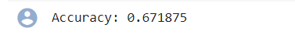

1. **CART (Classification And Regression Tree)**

# Load Dataset

import numpy as np

import matplotlib.pyplot as plt

import pandas as pd

from sklearn.datasets import load_boston

boston_dataset = load_boston()

boston = pd.DataFrame(boston_dataset.data, columns=boston_dataset.feature_names)

boston['MEDV'] = boston_dataset.target

names = boston_dataset.feature_names

#Library CART pada python  
from sklearn.tree import DecisionTreeRegressor

array = boston.values

X = array[:,0:13]

Y = array[:,13]

#print(X)

#print(Y)

from sklearn.model_selection import train_test_split

X_train, X_test, Y_train, Y_test = train_test_split(X, Y, test_size=0.3, random_state=1234)

#model = DecisionTreeRegressor(max_leaf_nodes = 20)

model = DecisionTreeRegressor(criterion='mse', max_depth=None, max_features=None,

max_leaf_nodes=50, min_impurity_decrease=0.0,

min_impurity_split=None, min_samples_leaf=1,

min_samples_split=2, min_weight_fraction_leaf=0.0,

random_state=None, splitter='best')

#Evaluasi

rt = model.fit(X_train, Y_train)

rt

import random as rnd

rnd.seed(123458)

X_new = X[rnd.randrange(X.shape[0])]

X_new = X_new.reshape(1,13)

#Prediksi Model

YHat = model.predict(X_new)

df = pd.DataFrame(X_new, columns = names)

df["Predicted Price"] = YHat

df.head(1)

from sklearn.metrics import r2_score

YHat = model.predict(X_test)

print(YHat)

#Menghitung Rata-rata Kuadrat

r2 = r2_score(Y_test, YHat)

print("R-Squared = ", r2)

**Hasil**



1. **Bagging**

#Impor Libraryimport numpy as np

from sklearn import datasets

from sklearn.model_selection import train_test_split

from sklearn.preprocessing import StandardScaler

from sklearn.linear_model import LogisticRegression

from sklearn.pipeline import make_pipeline

from sklearn.ensemble import BaggingClassifier

from sklearn.model_selection import GridSearchCV

#Load cancer dataset

bc = datasets.load_breast_cancer()

X = bc.data

y = bc.target

#membagi dataset

X_train, X_test, y_train, y_test = train_test_split(X, y, test_size=0.25, random_state=1, stratify=y)

#Melakukan pipelining   
pipeline = make_pipeline(StandardScaler(),

LogisticRegression(random_state=1))

**#Skema bagging**bgclassifier = BaggingClassifier(base_estimator=pipeline, n_estimators=100,

max_features=8,

max_samples=80,

random_state=1, n_jobs=5)

bgclassifier.fit(X_train, y_train)

print('Model test Score: %.3f, ' %bgclassifier.score(X_test, y_test),

'Model training Score: %.3f' %bgclassifier.score(X_train, y_train))

**Hasil**



**TUGAS PRAKTIKUM**

1. Melakukan visualisasi Tree
   1. Decision Tree

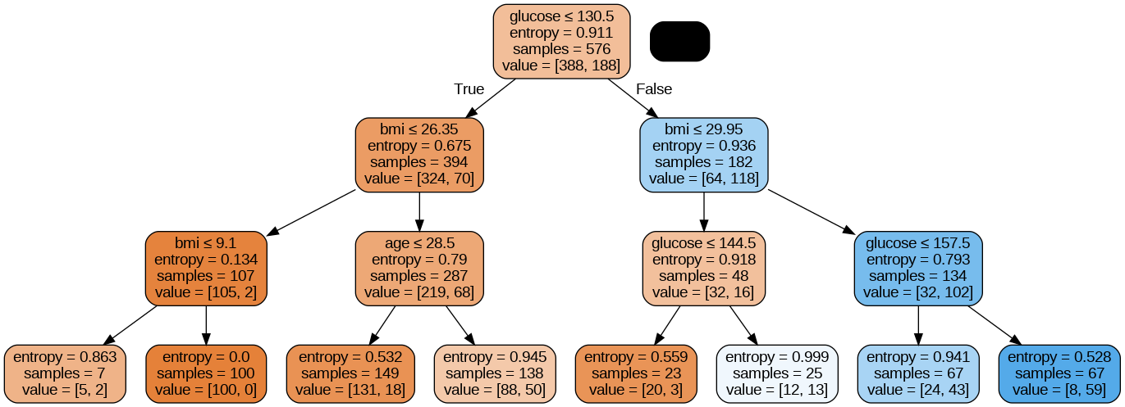

* 1. CART

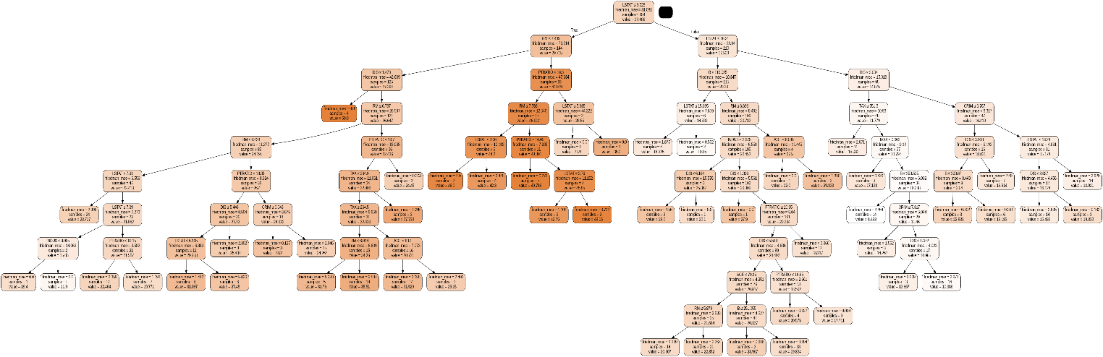

1. Melakukan tanpa skema bagging
   1. Pada Bagging



**DAFTAR PUSTAKA**

1. Richert W & Coelho LP. *Builidng Machine Learning System with Python*. 2013. Packt Publising. Birmingham, UK.